**Day 7 Task: Understanding package manager and systemctl**

**What is a package manager in Linux?**

In simpler words, a package manager is a tool that allows users to install, remove, upgrade, configure and manage software packages on an operating system. The package manager can be a graphical application like a software center or a command line tool like apt-get or pacman.

You’ll often find me using the term ‘package’ in tutorials and articles, To understand package manager, you must understand what a package is.

**What is a package?**

A package is usually referred to an application but it could be a GUI application, command line tool or a software library (required by other software programs). A package is essentially an archive file containing the binary executable, configuration file and sometimes information about the dependencies.

**Different kinds of package managers**

Package Managers differ based on packaging system but same packaging system may have more than one package manager.

For example, RPM has Yum and DNF package managers. For DEB, you have apt-get, aptitude command line based package managers.

**Tasks**

1. You have to install docker and jenkins in your system from your terminal using package managers\

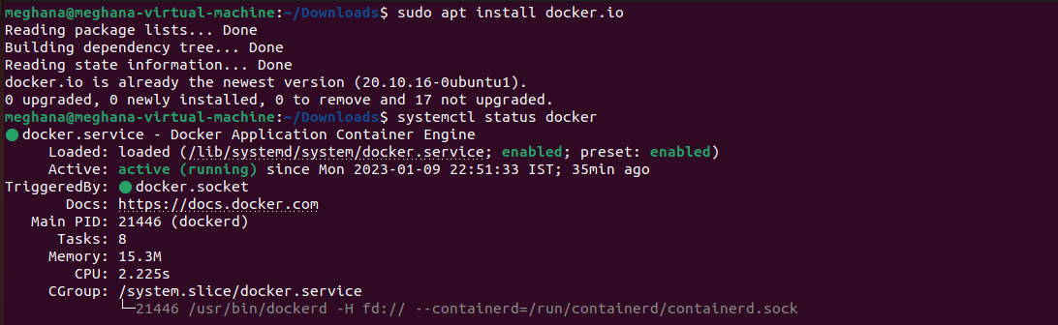

1. Write a small blog or article to install these tools using package managers on Ubuntu and CentOS

Jenkins requires Java to run. It will work with either [Java 8 or Java 11](https://phoenixnap.com/kb/how-to-install-java-centos-8), but some plugins aren’t compatible with Java 11. **This guide uses the open-source Java JDK 8 environment.**JDK stands for Java Developer Kit, and it includes all the files needed to run Java applications.

Step 1: Install Java

sudo dnf install java-1.8.0-openjdk-devel

Java –version

Step 2: Add Jenkins Repository on CentOS 8

# rpm --import <https://pkg.jenkins.io/redhat-stable/jenkins.io.key>

Since Jenkins is not available in CentOS 8 repositories, therefore we are going to add Jenkins Repository manually to the system.

Begin by adding Jenkins Key

# rpm --import https://pkg.jenkins.io/redhat-stable/jenkins.io.key

Now append Jenkin’s repository to CentOS 8.

# cd /etc/yum/repos.d/

# curl -O https://pkg.jenkins.io/redhat-stable/jenkins.repo

Step 3: Install Jenkins on CentOS 8

Having successfully added Jenkins repository, you can proceed to install Jenkins by running.

# dnf install jenkins

Install Jenkins on CentOS 8

Once installed, start and verify the status of Jenkins by executing the commands

# systemctl start jenkins

# systemctl status jenkins

Start and Verify Jenkins Status.

Next, you need to configure the firewall to allow access to port 8080 which is used by Jenkins. To open the port on the firewall, run the commands.

# firewall-cmd --add-port=8080/tcp --permanent

# firewall-cmd --reload

Open Jenkins Port on Firewall

Step 4: Setting up Jenkins on CentOS 8

With the initial configurations done, the only remaining part is setting up Jenkins on a web browser. To achieve this, browse your server’s IP address as shown:

http://server-IP:8080

**Command to install Jenkins on Ubuntu**

sudo apt-get install openjdk-8-jdk

wget -q -O - https://pkg.jenkins.io/debian-stable/jenkins.io.key | sudo apt-key add -

sudo sh -c 'echo deb https://pkg.jenkins.io/debian-stable binary/ > /etc/apt/sources.list.d/jenkins.list'

sudo apt-get update

sudo apt-get install jenkins

**systemctl and systemd**

systemctl is used to examine and control the state of “systemd” system and service manager. systemd is system and service manager for Unix like operating systems(most of the distributions, not all).

**Tasks**

1. check the status of docker service in your system (make sure you completed above tasks, else docker won't be installed)



stop the service jenkins and post before and after screenshots

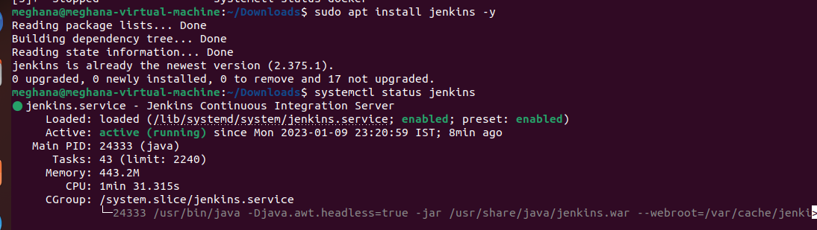

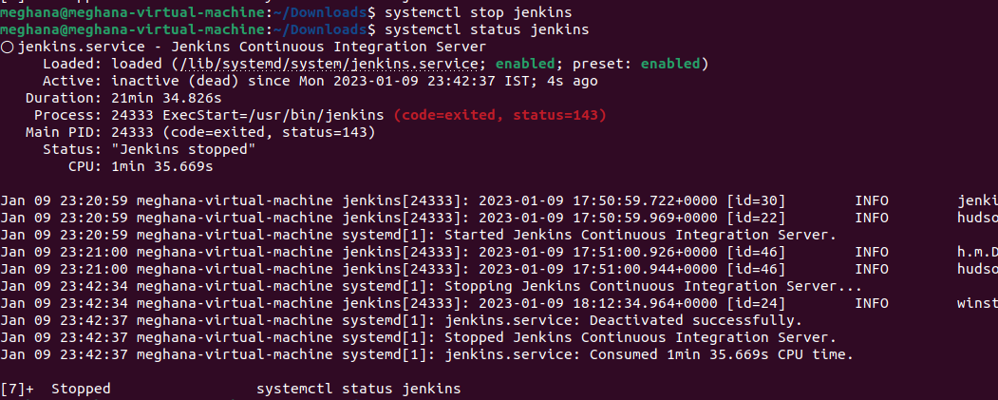

1. read about the commands systemctl vs service

eg. systemctl status docker vs service docker status